ISTE-230 Introduction to Database and Data Modeling

## Practice Exercise # 8 – ‘IS-A’ Relationships

**Name:** Brian Zarzuela

**Problem #1**

Given the following business rules, please extend the E-R diagram provided below.

* Each CONTACT doesn’t have to be, but could be classified as any combination of the following: CO-WORKER, VENDOR, and PERSONAL.
* If the CONTACT is a CO-WORKER, then the office_number will be stored.
* A VENDOR will have one or more VENDOR_TYPEs.
* A VENDOR TYPE is uniquely identified by vendor_typeID. In addition, a description is provided.
* A VENDOR_TYPE doesn’t have to apply to any instances of VENDOR, but could apply to many different VENDORs.
* If the CONTACT is a PERSONAL, then the street, city, state, zip should be tracked for the home address.
* Every PERSONAL CONTACT, must be either a RELATIVE or a FRIEND, but never both.
* For a RELATIVE the relationship will be stored, such as mother, father, cousin, etc.
* For a FRIEND, where that friend was met will be stored, such as elementary school, middle school, high school, college, camp, etc.

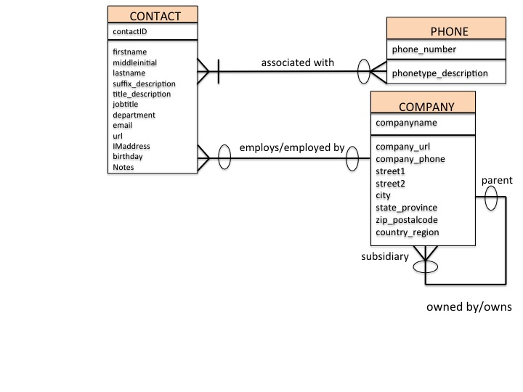

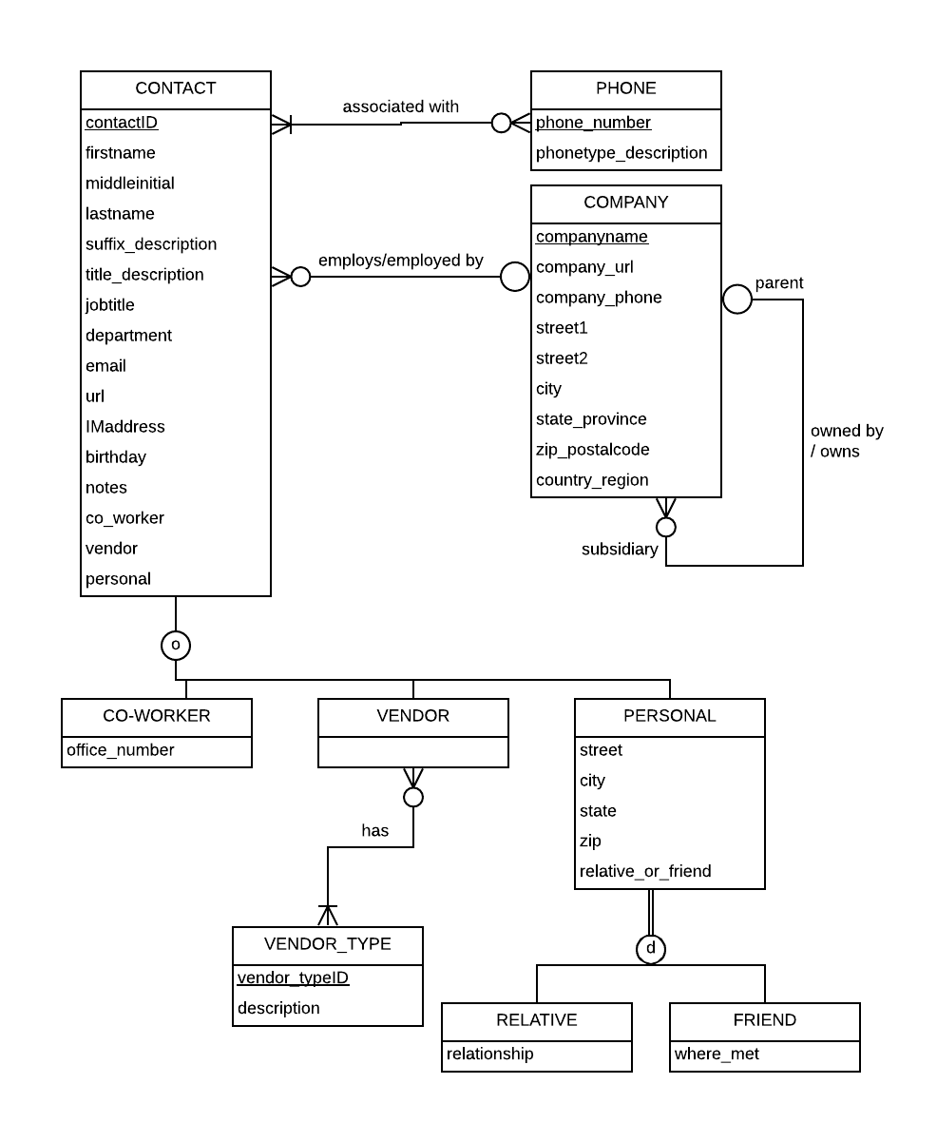

**YOUR ANSWER (Diagram above completed):**

**Problem #2**

Using your knowledge of the scenario described above, please answer the following questions.

A. If a discriminator were to be added to CONTACT, what attribute(s) would you add?

**YOUR ANSWER:** co_worker, vendor, peronal representing each CONTACT subtype in which each attribute would be a boolean to denote whether or not a CONTACT was of that particular type

B. If a discriminator were to be added to PERSONAL, what attribute(s) would you add?

**YOUR ANSWER:** relative_or_friend denoting whether the respective CONTACT was a FRIEND or RELATIVE